Communication preferences

Template

Step 1:

1. In the first column, from the list of behaviors below, please choose the top 7 that most resonate with you, by marking a tick ü next to it.
2. On the second column, from the 7 behaviors that you have ticked, now select your top 5 and rank them from most like you (1) to least like you (5).

|  |  |  |
| --- | --- | --- |
| Behavior | My top 7 ü | Rank your top 5  *(1 = most like you; 5 = least like you)* |
| Likes challenges | ü | 5 |
| Results focused | ü | 2 |
| Competitive |  |  |
| Determined | ü | 1 |
| Assertive |  |  |
| Decisive |  |  |
| Risk Taker |  |  |
| Sensitive to others |  |  |
| Sociable |  |  |
| Emotional | ü | 1 |
| Stimulating |  |  |
| Outgoing |  |  |
| Optimistic | ü | 4 |
| Enthusiastic | ü | 3 |
| Tactful |  |  |
| Calm |  | 1 |
| Patient |  |  |
| Dependable | ü | 2 |
| Supportive |  |  |
| Accommodating |  |  |
| Procedure orientated |  |  |
| Precise |  |  |
| Private |  |  |
| Systematic |  |  |
| Restrained |  |  |
| Likes numbers |  |  |
| Perfectionist |  |  |
| Critical of mistakes |  |  |

Step 2:

Now please complete your research. Here is a reminder of DiSC. The example behaviors are drawn from the previous table.

Introducing the DiSC model

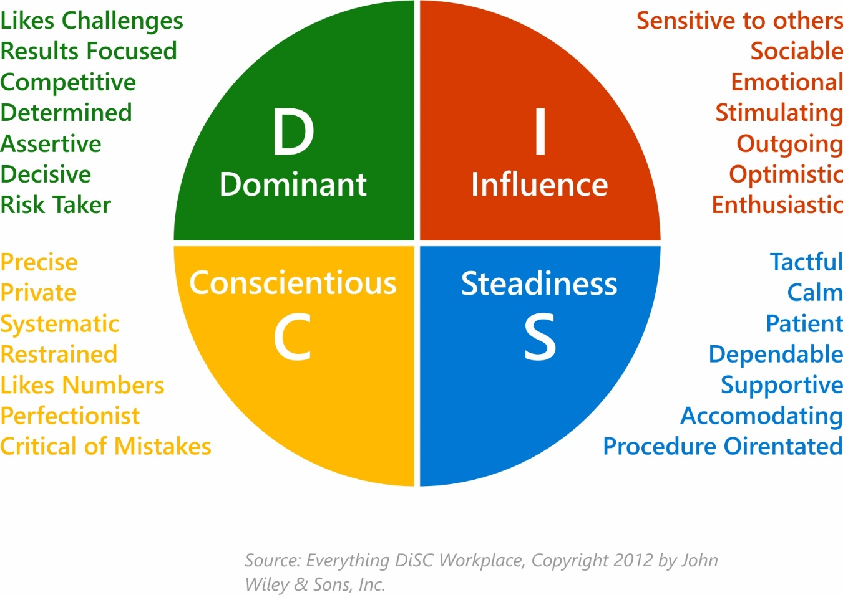

Step 3:

Following your research, answer the final 2 questions below.

1. What have you learned about yourself from the DiSC model?

I am a mixture of Dominance (D) and Influence (I). From the research I feel this is a

true reflection as I can identify with many of the behaviors and can see how this

comes across when I communicate and how I prefer people communicate with me.

I think I flex between D and I, depending on the situation. At work I’m more likely to

communicate in more of a D approach, but at home I think I communicate using I

more often. I find this really interesting that my ‘work’ and ‘home’ styles are slightly

different (even though they do cross over) and I can now easily identify this. This

means that if I can identify between these 2 styles, then I should be able to start to

identify other people’s styles and learn to adapt to them.

In my predominant work style, I could be seen as an abrupt communicator due to

where my focus is – on results, getting the job done, being assertive and being

challenged. This isn’t to say that this is my only way of communicating, as I do care

what other people have to say and how they feel (this is my I preference showing),

but this feels more natural when I am at home and communicating with friends and

family.

1. What have you learned about DiSC and its value when communicating with others?

I now understand why I get frustrated when people communicate with me in a

‘Steadiness’ or ‘Conscientious’ style, as this is not my natural way of communicating.

It has allowed me to understand this more from their perspective and appreciate why

they communicate in this manner. I also now recognize why I need to adapt to their style at times, as my style probably frustrates them.

I think DiSC will help me adapt my conversation styles based on the other person’s

preferences. I now understand how to distinguish between the different

communication preferences. If someone is focusing their conversation around

numbers and being systematic, then I need to be mindful of this, so they get what

they need out of the conversation. Plus, this will help me influence the conversation

as they will be more likely to be interested in what I’ve got to say and value my input

if I respond to their preferred communication style.

I am also going to generally pay more attention to how other people communicate

so that I can determine what their preference may be. Then I will be able to plan how to

interact and communicate with that person more effectively, so it meets their communication style.

I think this will take a lot of practice, so I’m going to start doing this with my friends

and trusted colleagues first. I will see if I can identify their communication style, then

adapt my conversation and language to suit them. I will seek feedback from them

about how effective this is and what I could continue to work on to improve the way

I respond to different communication styles.